**Portuguese as a Foreign Language Intermediate & Advanced (PFL Intermediate & Advanced) Supply List**

4x pocket folder with fasteners for loose papers

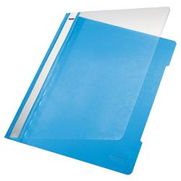

1x A4 non-spiral, lined notebooks with a label

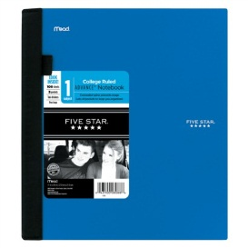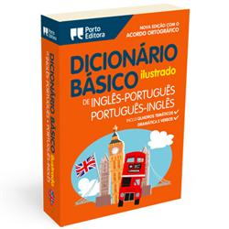

1x pocket dictionary (Dicionário Básico Ilustrado Inglês/Português Português /Inglês da *Porto Editora*)



1 box of coloring pencils

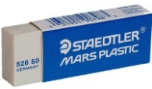

1 eraser

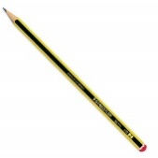

2 pencils



1 box of Ziploc bags

*CAISL does not endorse any of the supply brands shown above