**Portuguese as a Foreign Language Beginner (PFL Beginner) Supply List**

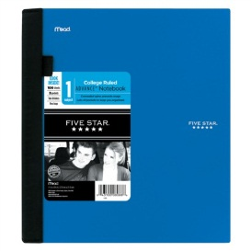 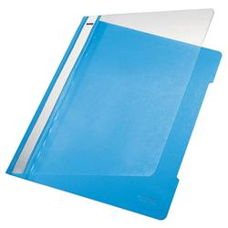

4x pocket folder with fasteners for loose papers

1x A4 non-spiral, lined notebooks with a label

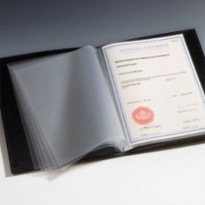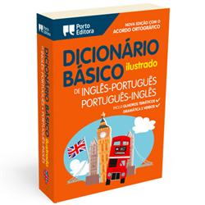

1x pocket dictionary (Dicionário Básico Ilustrado Inglês/ Português Português /Inglês da *Porto Editora*)

1 Folder with 20 transparent sleeves

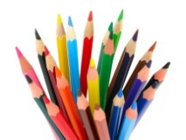

10x blank labels (to write name)

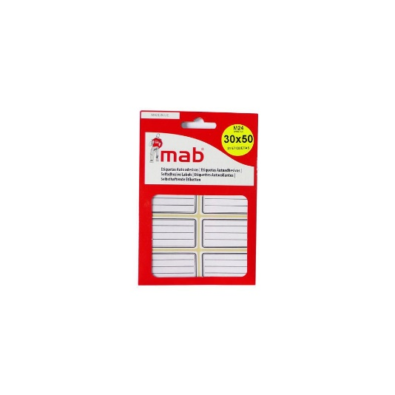

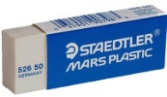 1x box of coloring pencils

1x eraser

*CAISL does not endorse any of the supply brands shown above