**Fifth Grade Supply List**

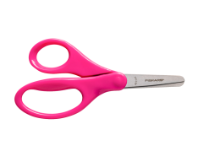Welcome to Fifth Grade! This year will be a busy and exciting year for your child. Here is what your fifth grader will need to be prepared and stay organized in our class:

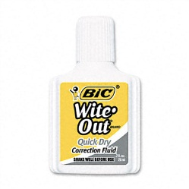

3x UHU glue stick

1x bottle of whiteout

1x set of colored markers or any other coloring materials.

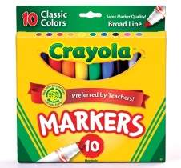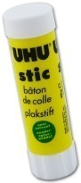

1x pair of scissors

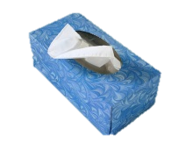

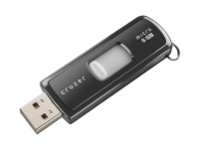

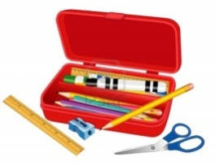

1x ruler (6 inch or 10cm size is sufficient)

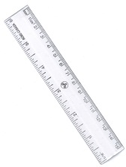

1x pen drive (this item is available at the CAISL store [here](http://www.caislisbon.org/page.cfm?p=601))

1x pencil case with pencils, erasers, sharpener etc.

1x box of tissues

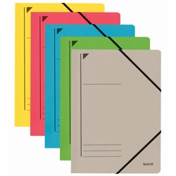

1x whiteboard marker

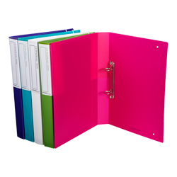

1x red pen or thin marker

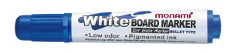

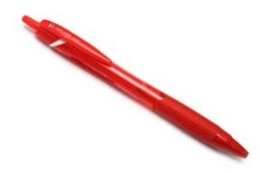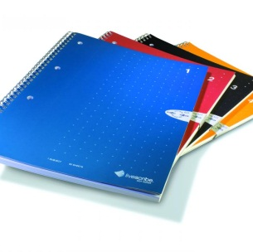

1x two-ring binder with dividers

1x plastic folder with straps

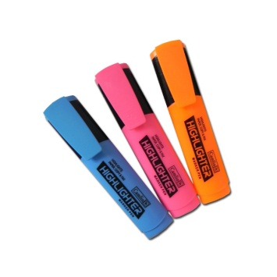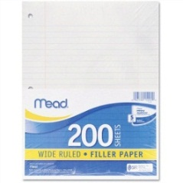

5x A4 notebooks

5x different color highlighters

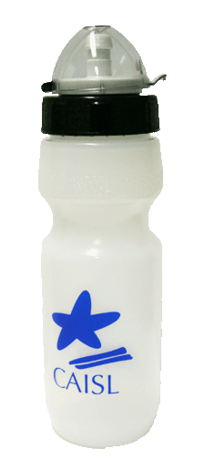

1x loose- leaf lined pad

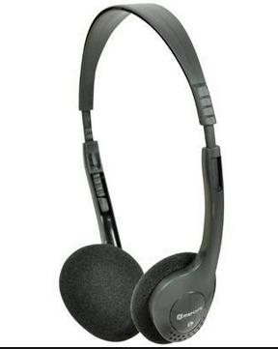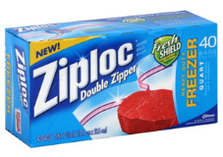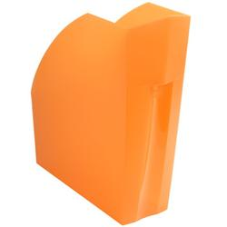

1x reusable water bottle (this item is available at the CAISL store [here](http://www.caislisbon.org/page.cfm?p=601))

1x pair of computer headphones

1x box of medium Ziploc bags

1x wide notebook storage box

*School will provide a small assignment notebook, and other materials will be asked for as needed.

*CAISL does not endorse any of the supply brands shown above.