**Second Grade Supply List**

Welcome to Second Grade! Second grade will be a busy and exciting year for your child. They will be reading a lot for enjoyment, beginning to read for information and sharing their experiences and ideas through writing. As you might imagine, this will result in quite a bit of paperwork and require quite a few supplies. Here is what your second grader will need to be prepared and stay organized in our class:

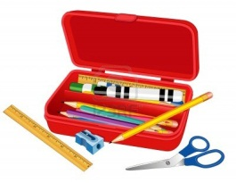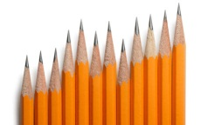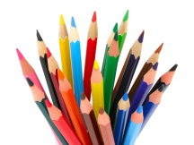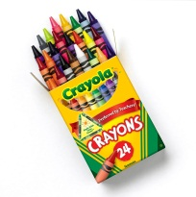

1x pencil case

12x pencils with erasers

1x box of crayons and colored pencils

(no markers)

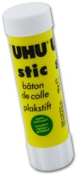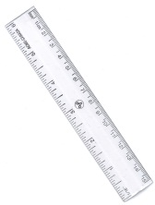

2x glue sticks *(*one will go directly into the pencil box, the other may be kept home to replenish supplies as needed*)*

1x inch and centimeter ruler

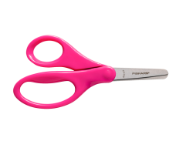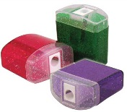

1x pair of child-friendly scissors

1x sharpener with a cover

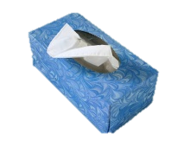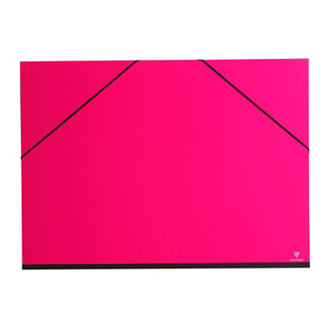

1x tissue box

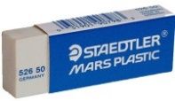

2x A4 notebooks (lined)

Language Arts Journal

Science/Social Studies

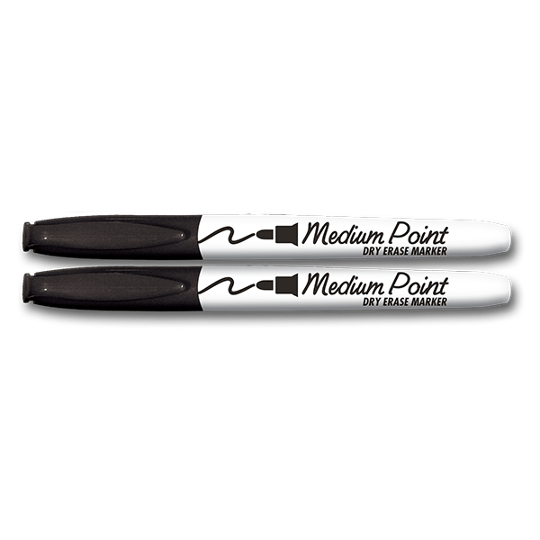

4x folders labeled:

* Home
* Science & Social Studies
* Busy Bee Folder

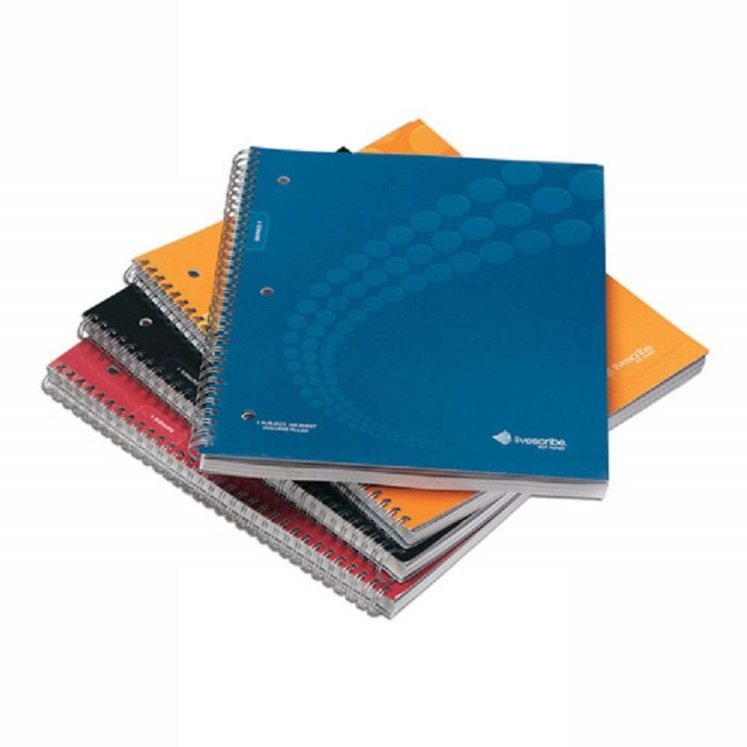

2x white erasers (one for school, one at home to replenish the supply when needed)

1x dry erase marker

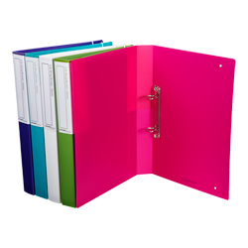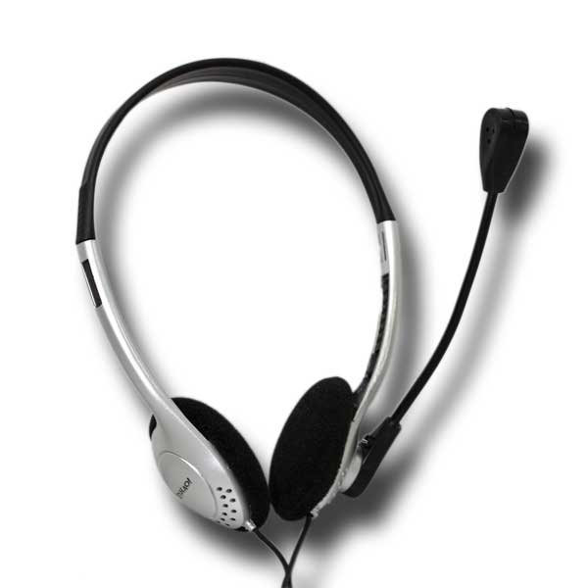

2x binders (preferably not wider than 2 in/5cm)

1x pair of computer headphones

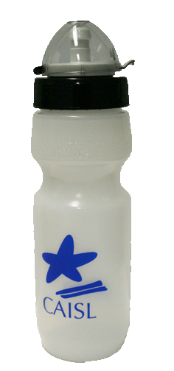

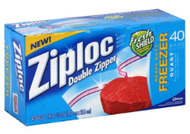

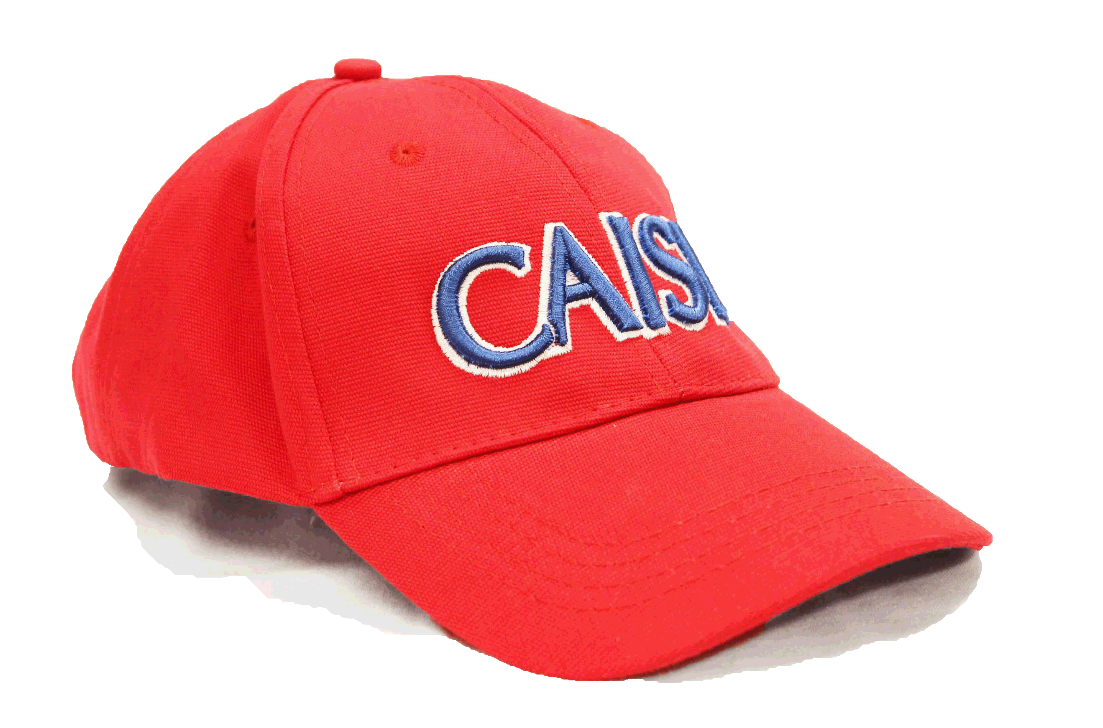

1x non-disposable water bottle to keep at school (this item can be purchased at CAISL - see it [here](http://www.caislisbon.org/page.cfm?p=601))

1x box of Ziploc bags, large enough to safely store a small book

1x red cap (this item can be purchased at CAISL - see it [here](http://www.caislisbon.org/page.cfm?p=601))

Please personalize all supplies with your child’s name to avoid mix-ups or lost items. You are welcome to be as creative as you would like in decorating the supplies. These supplies will help in the smooth running of our classroom!

*CAISL does not endorse any of the supply brands shown above